**Week 3**

**Interviewing**

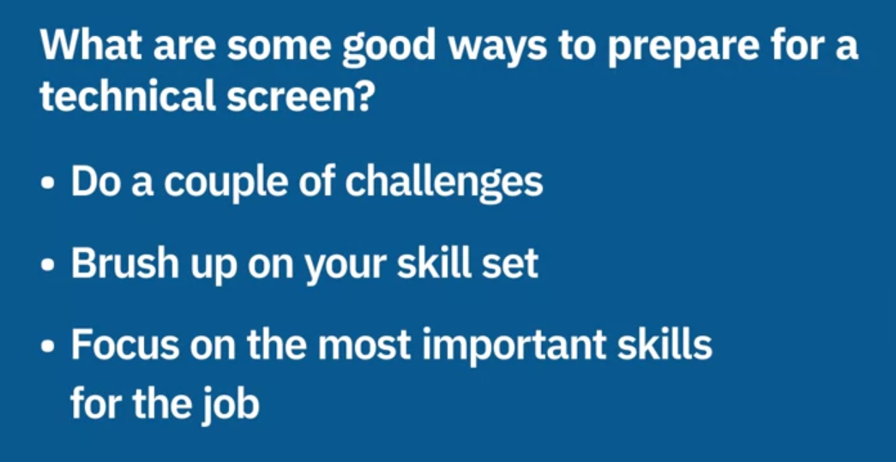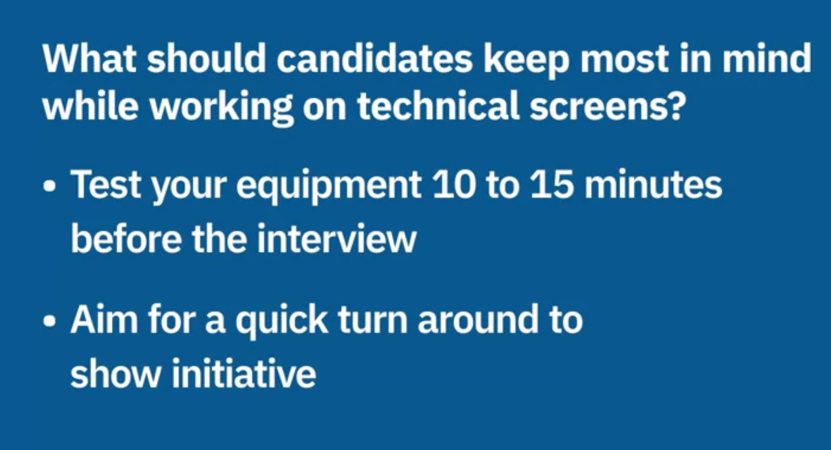

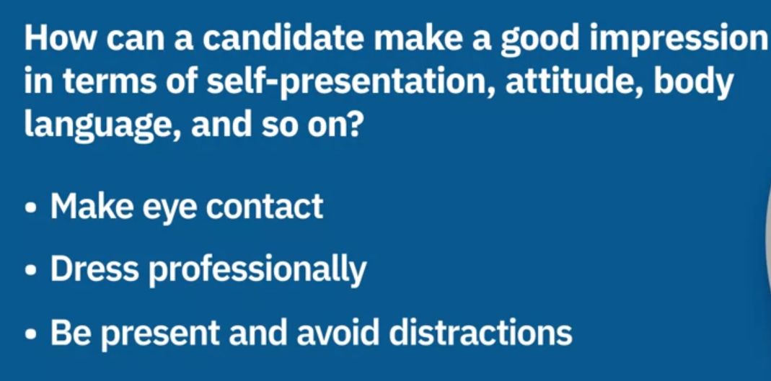 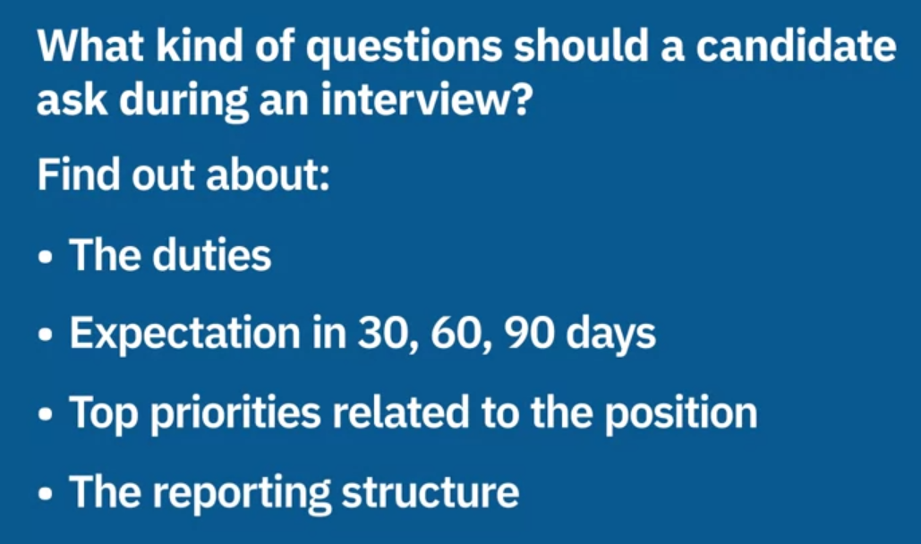

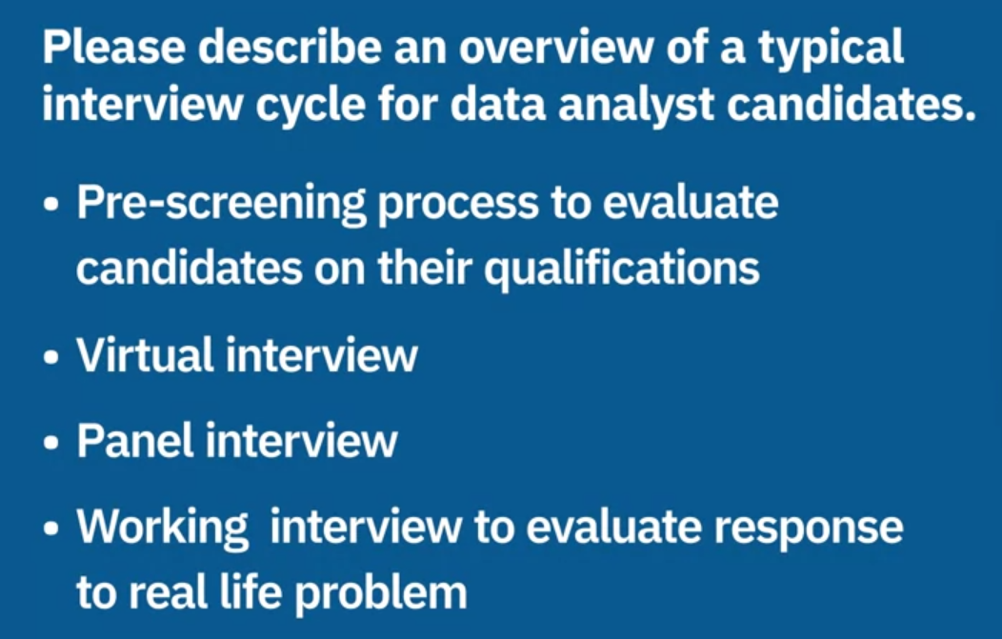

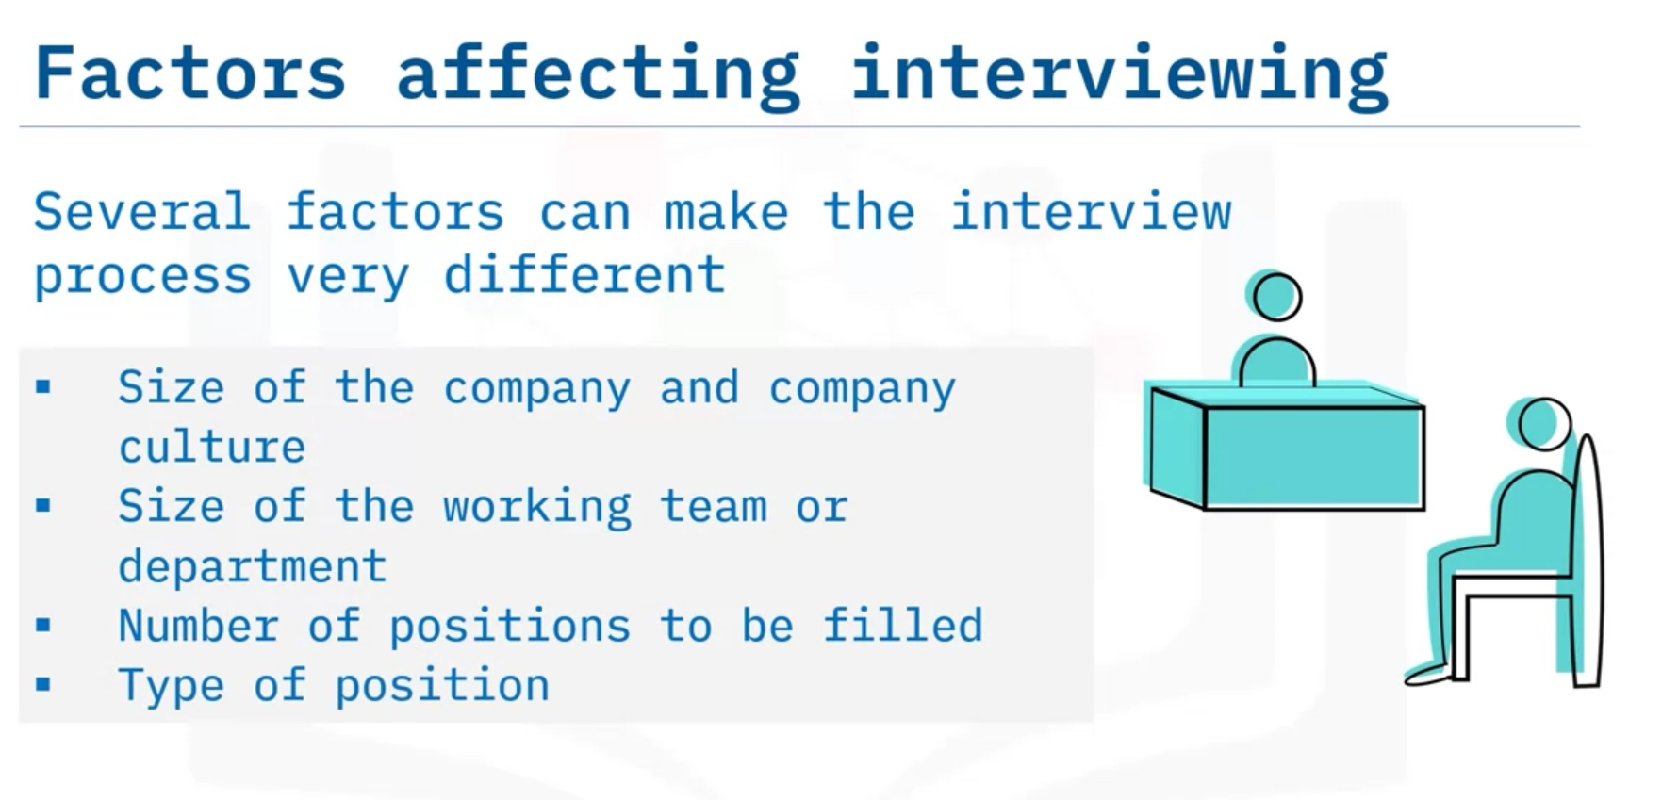

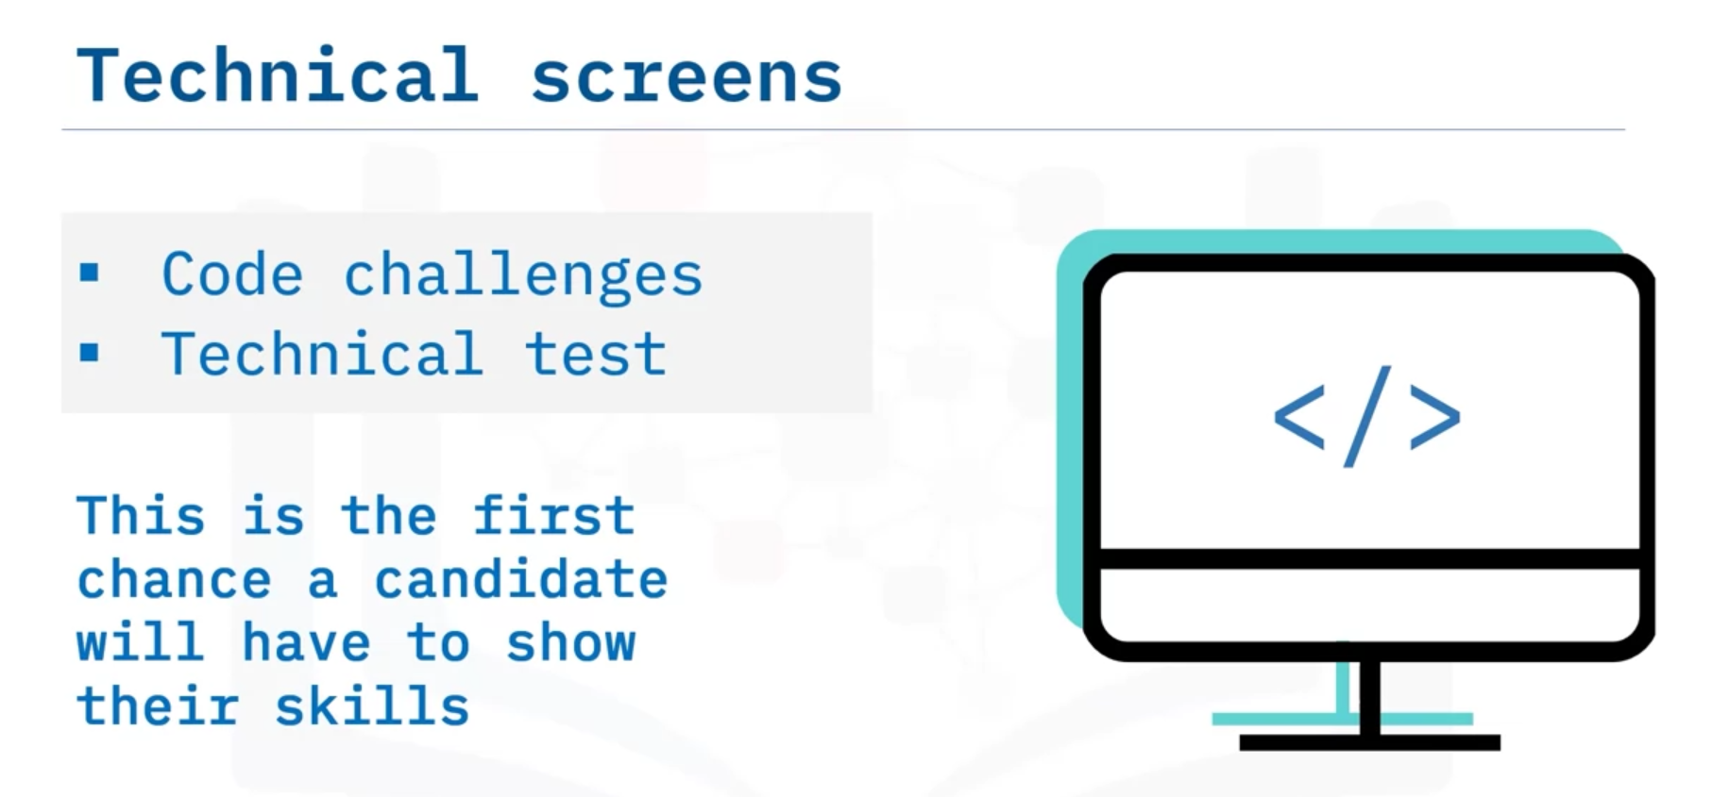

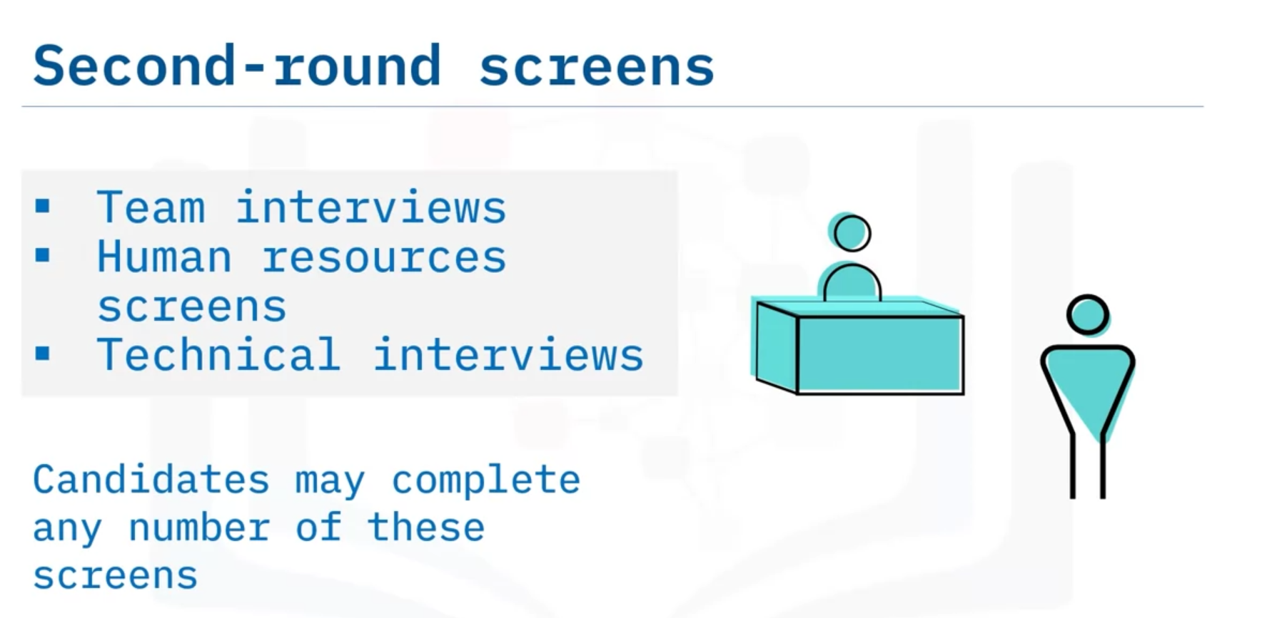

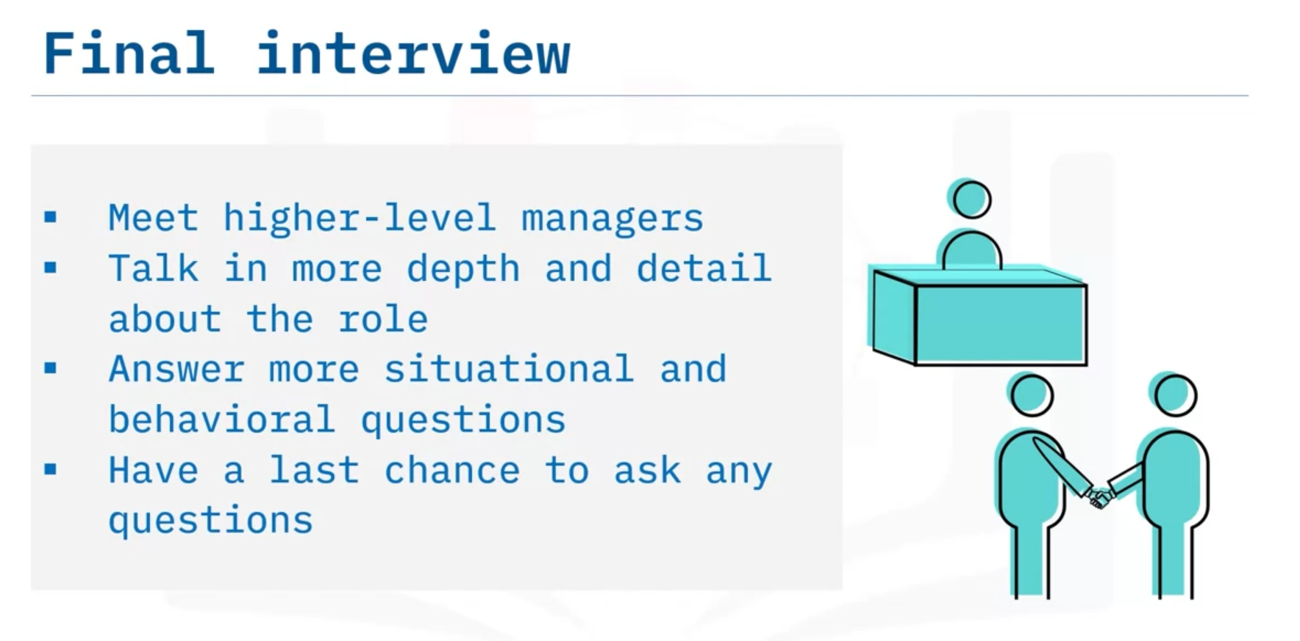

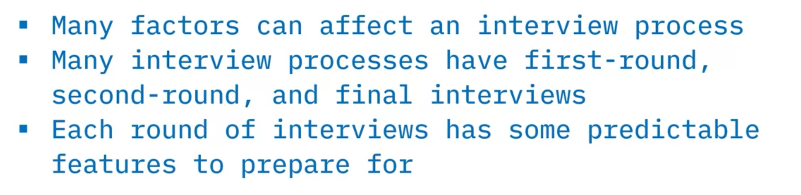

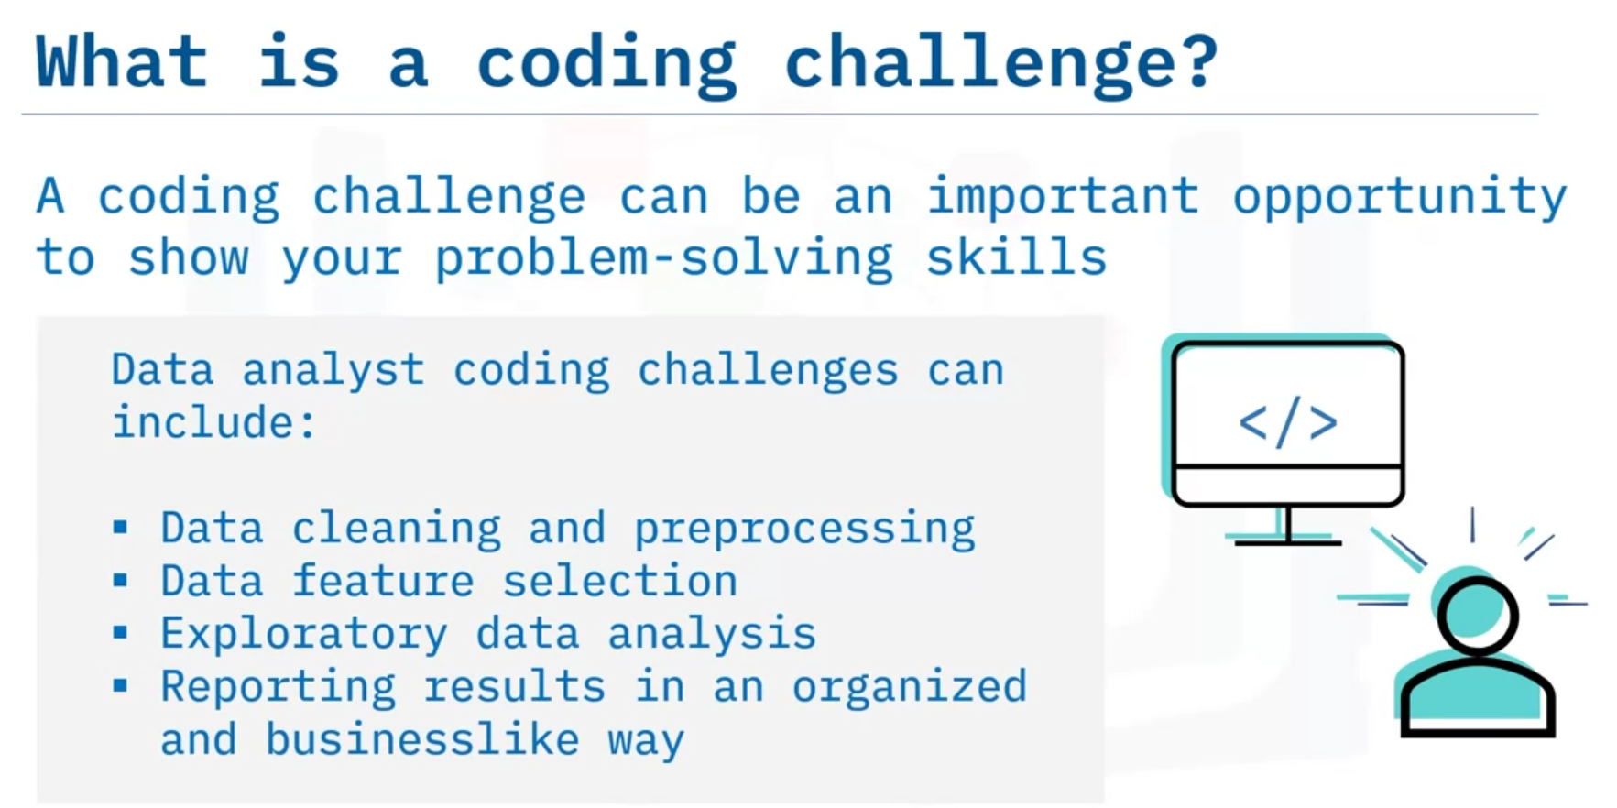

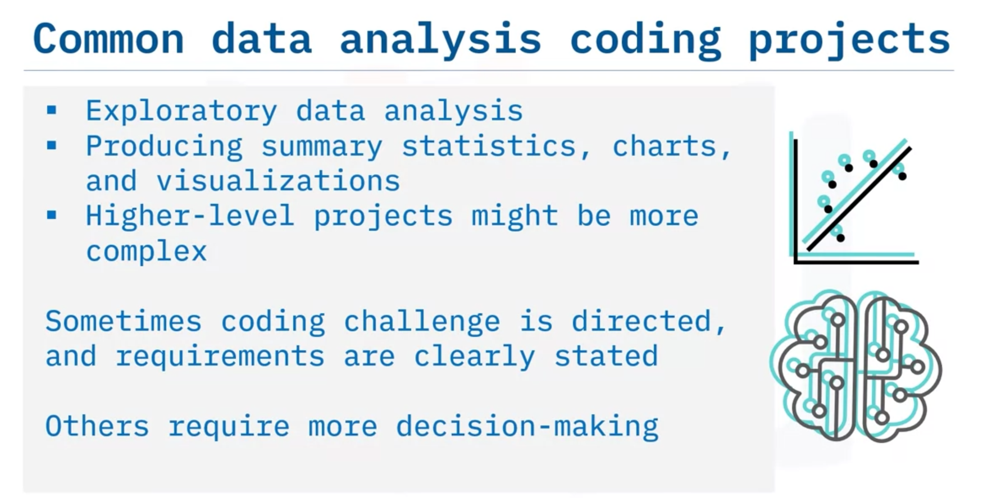

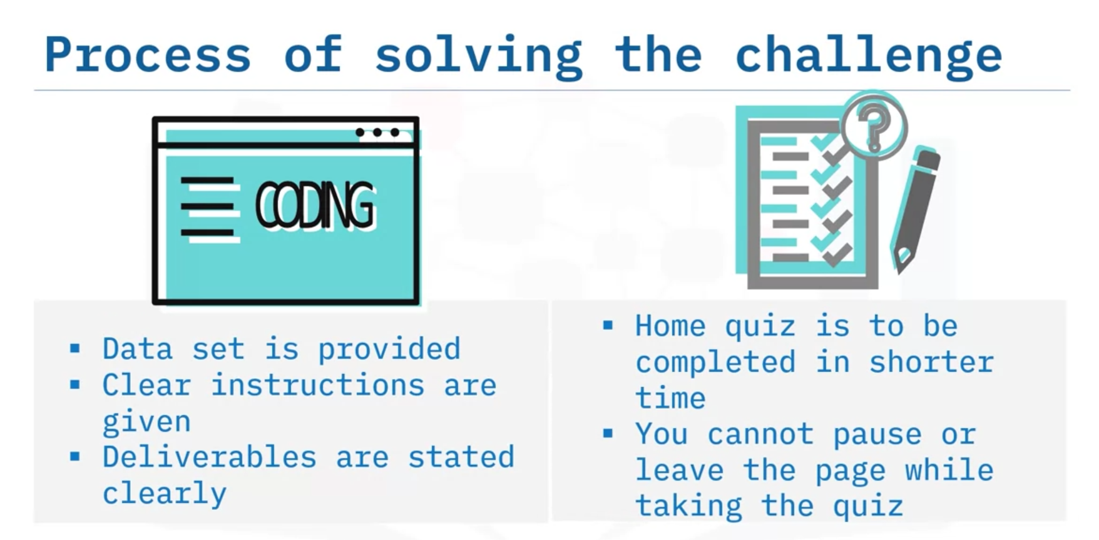

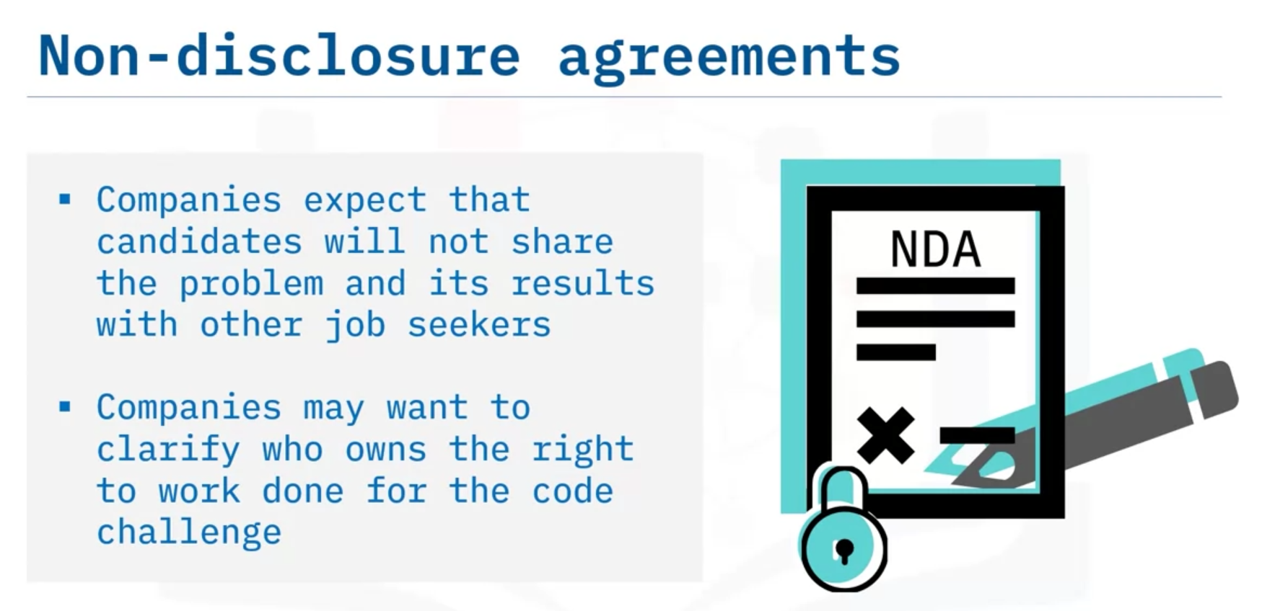

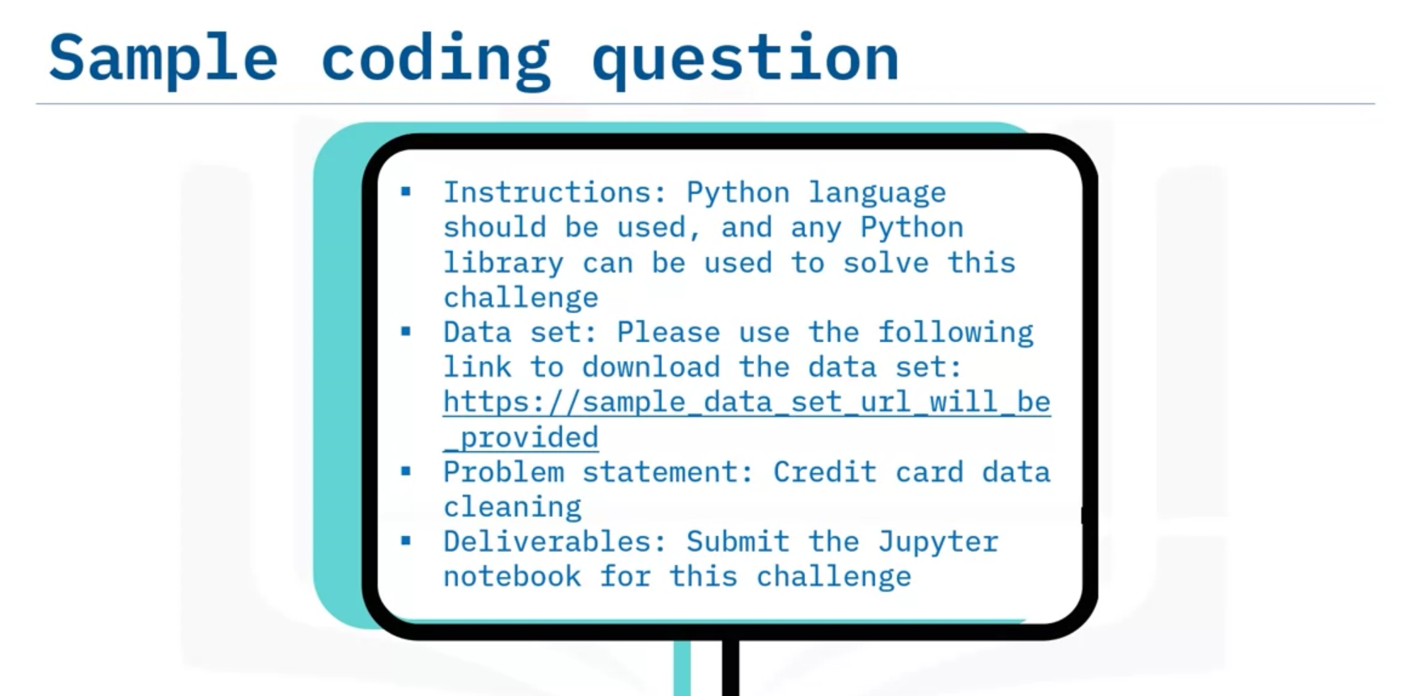

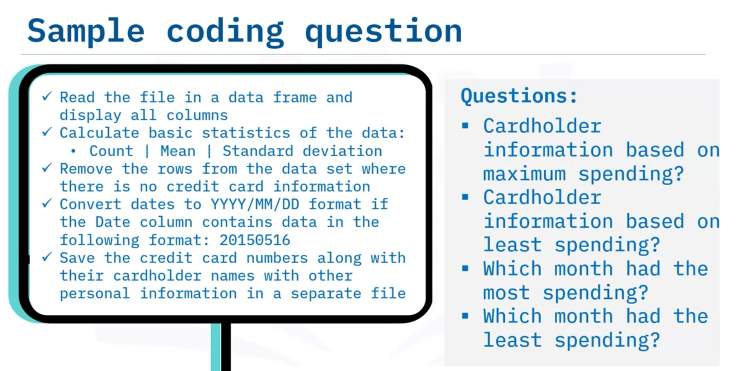

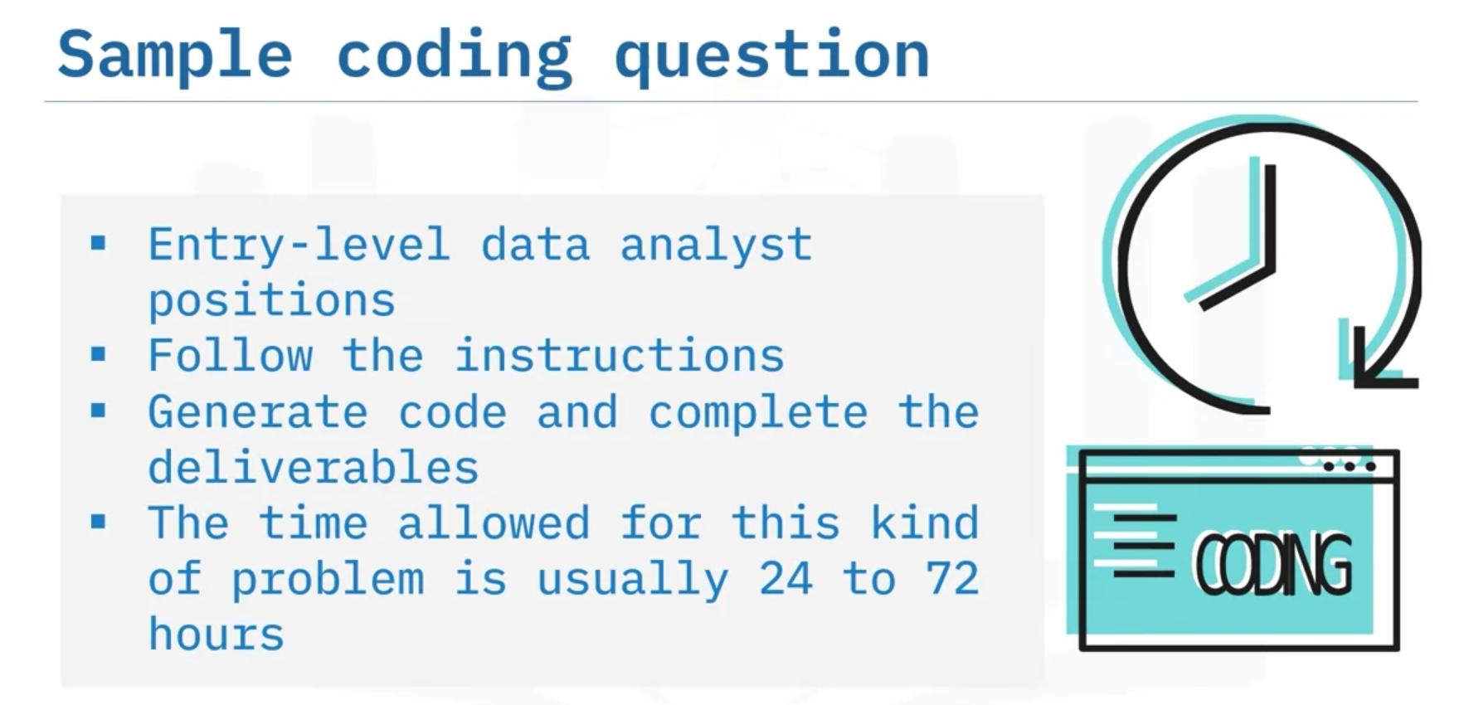

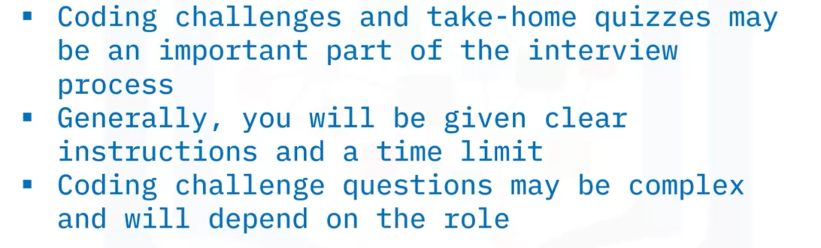

# Second Round Screening

If you receive an invitation to a second job interview, you deserve to be congratulated. The interviewers involved in the first round were convinced that you may be a good fit.

Usually, second-interview questions require you to share more about your competencies, in addition to your ethics and outlook about your work. Employers will also want to make sure you are able to work well within the company’s culture. Your answers should align with the company’s mission and the role of the position you are applying for. Remember that the company has an open position because they need to grow in an area of work or optimize a process, so it’s important to showcase how you can contribute to fulfill its purpose.

## General second-round preparation

To prepare for a second-round job interview, it is important to reflect on how the first interview went and plan accordingly. Here are some possible considerations:

* What went well? Use the experience wisely and to your advantage for the next time.
* Make note of the points that were discussed the most and which seemed to be more important or of particular interest to your interviewers. Prepare follow-up questions on those topics.
* Would you have answered a particular question differently? Was there a question that caught you off guard or was unexpected? How might you have responded instead? Think about what you’ll say if you get another chance to address this topic.
* Recall the names and job positions of those you met at the previous interview.

Did you have any thoughts, questions, or concerns that came up after the first interview was over? Make note of them in case there’s an opportunity to discuss them.

## Types of second-round interviews

Second-round interviews are usually more focused than first or final interviews. You may meet with the same interviewers, but you will more likely meet with team leaders, technical managers, HR personnel, or others with distinct areas of interest. You may meet with higher-level or executive management, but each company proceeds differently.

## HR Screen

A screen by a human resources (HR) professional will usually focus on very basic questions about your past experience and understanding of the company and its culture. It may even take place as a first interview. It generally won’t get into the nuts and bolts of a position, and there won’t be involved technical questions. Here are some questions you might expect from this screen:

* What motivated you to apply for this job?
* What attracted you to our job listing?
* Why did you leave your last job?
* What is your ideal working environment?
* What do you know about our company’s product or services?
* What are your expectations about salary and other compensation?

With these questions, try to relate your experience to the answers and project a positive attitude. Think ahead about how to answer the questions that seem awkward; for example, if you left your last position for negative reasons, consider how to frame that neutrally and professionally. Don’t relate your specific compensation history if asked, but be candid about your expected rates and how flexible you can be.

## Team leader

If you interview with a team leader (often a project manager or other management), they may want to discuss the team you’d be working with and how they approach projects. There may be some discussion of your skills, but less than you would do with a technical screen. The team leader will be interested in understanding your work style, so they may ask you more behavioral questions. Here are some examples of questions you might expect.

* Tell me about a few of the first things you would do in this role.
* Give a few examples of best practices in data science.
* What’s a data science project you would want to work on at our company?
* Tell me about a time you experienced conflict with a colleague and how you resolved it.
* Tell me about a time when your project failed. What did you do and what did you learn?
* Do you prefer to work closely with a team or mostly by yourself?
* How are you motivated?
* How do you start learning about a topic you don’t know about yet?

Your answers to these questions will tell a hiring manager a lot about how you see your role and the value you bring to an organization. Build rapport with those who are present; make an effort to address interviewers by their name if you have met them before. Project yourself as an already-hired team member and discuss specific things that you'd want to learn and accomplish. Focus your responses on how you want to grow as a professional while exceling in your new role within the company.

Interviewers sometimes ask questions, such as, “If you could have a superpower, which would it be and why?” Although it may initially seem as off-topic or unrelated to the job position, the way you respond to these questions may reveal how you handle the unexpected stress, or perhaps gauge your creativity or the way you approach problems. Answer honestly and have fun when you think about and answer these kinds of questions.

## Technical screen

A technical screen is usually conducted by a coding team leader or higher-level developer. Its purpose is to assess your technical skills and compare them to the skills needed for the position. Most of the questions will be about technical topics and team skills. Here are examples of the type of questions you may hear.

* What coding languages do you know?
* What are some of your favorite tools?
* How do you begin working on a problem you’ve been assigned?
* What do you do when you reach something you don’t understand?
* How do you stay on schedule and manage your time?
* How do you prepare for a presentation?

There will usually be some specific problems to solve as well. Don’t worry – the interviewer won’t expect you to provide a perfect solution at once. These questions are meant to understand how you approach a problem and your thinking strategies.

Conclusion

No matter how you think the second interview goes, always try to end on a positive note and be explicit about your interest in the role. Express appreciation and thank each interviewer for the opportunity to interview again. Offer a sincere smile, handshake, and a wish that they are able to find the perfect fit for the job. Being enthusiastic and positive can leave a lasting impression and set you apart. Ask for contact information in case you need to reach them and respond promptly with any material they requested, such as links to your portfolio. Send thank-you notes the same day and follow up if you haven’t heard back within the estimated timeframe.

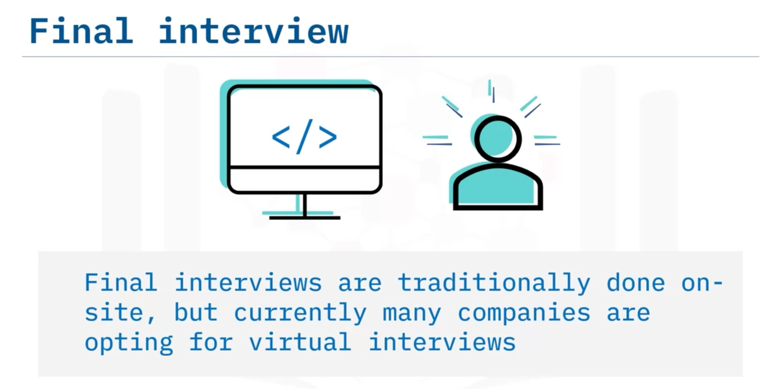

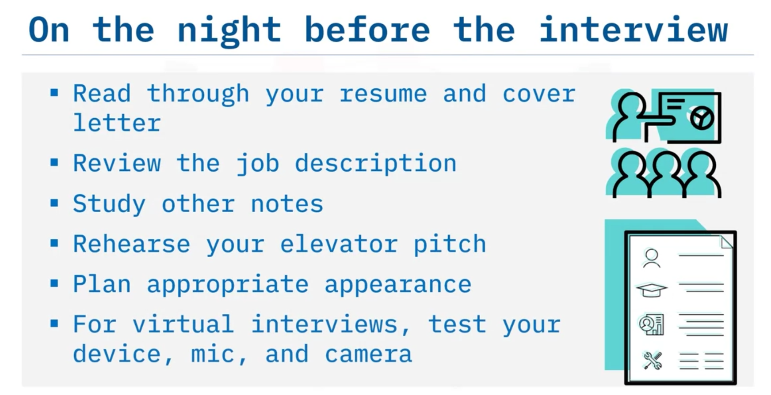

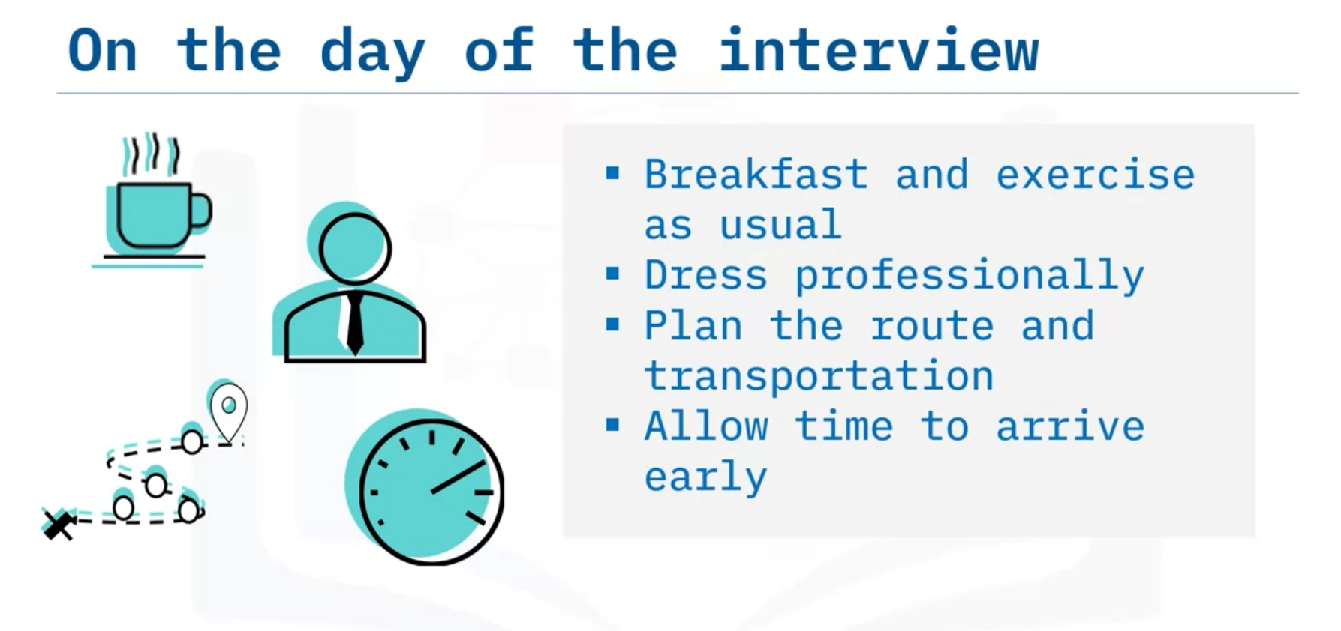

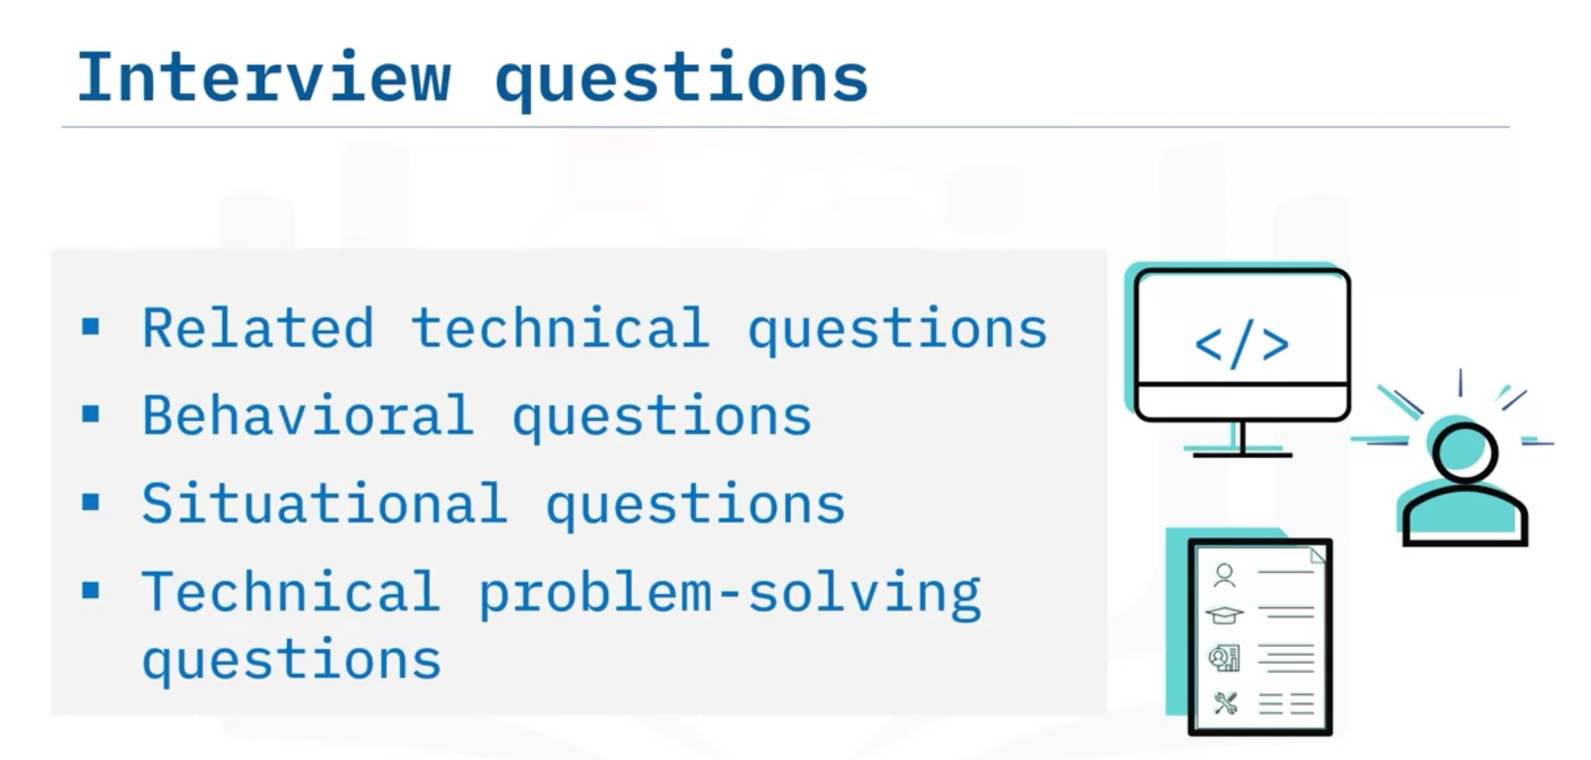

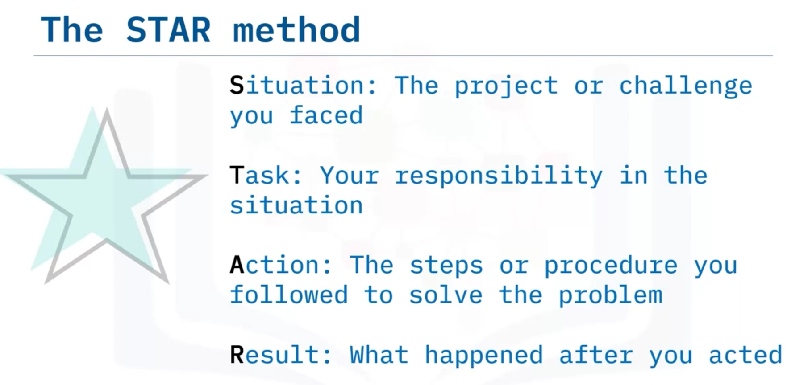

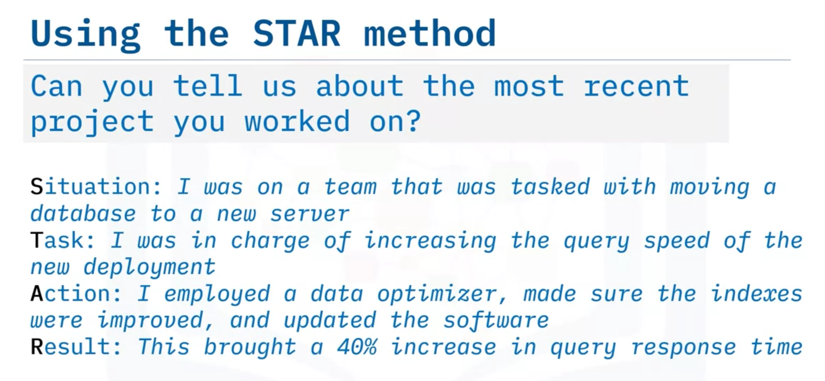

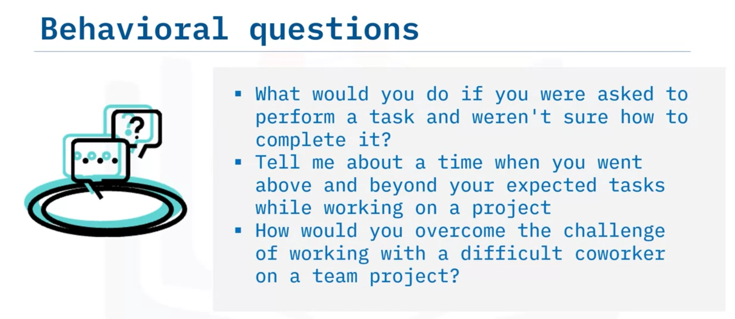

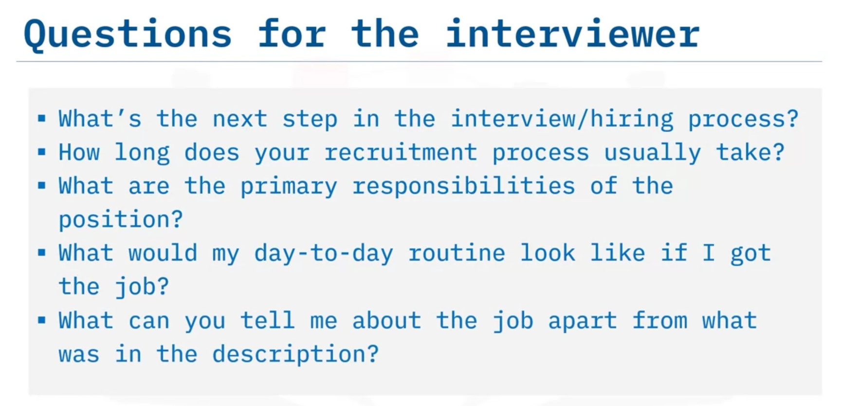

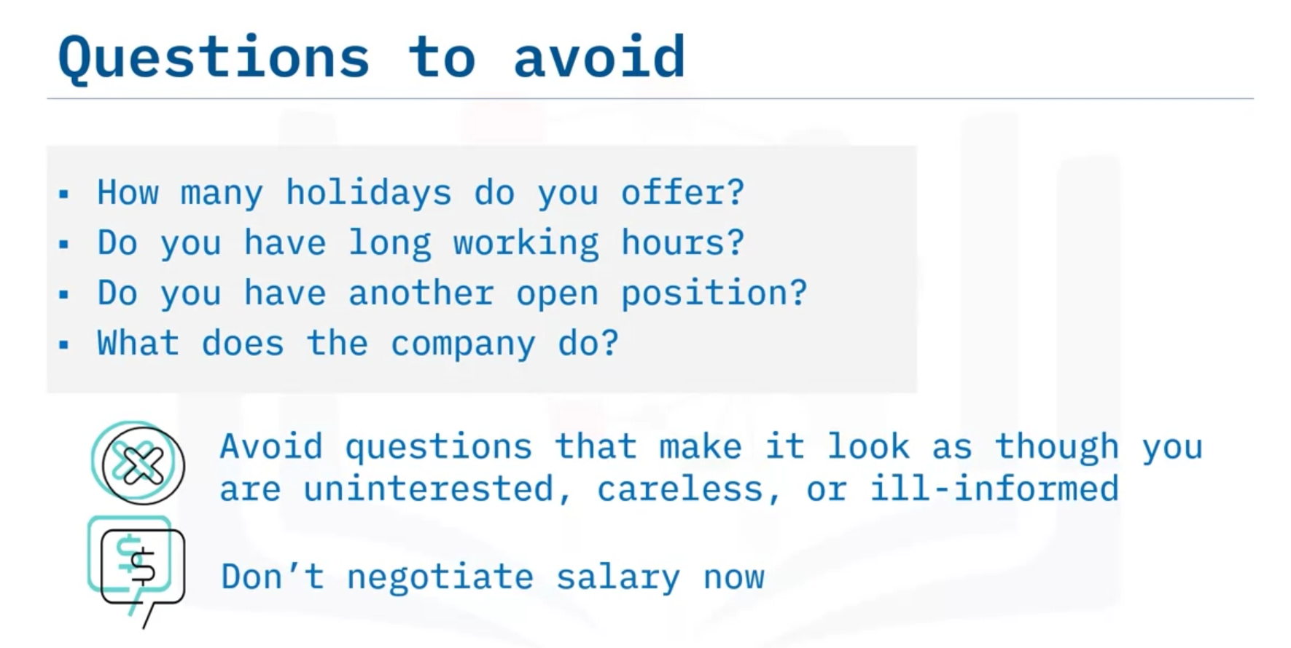

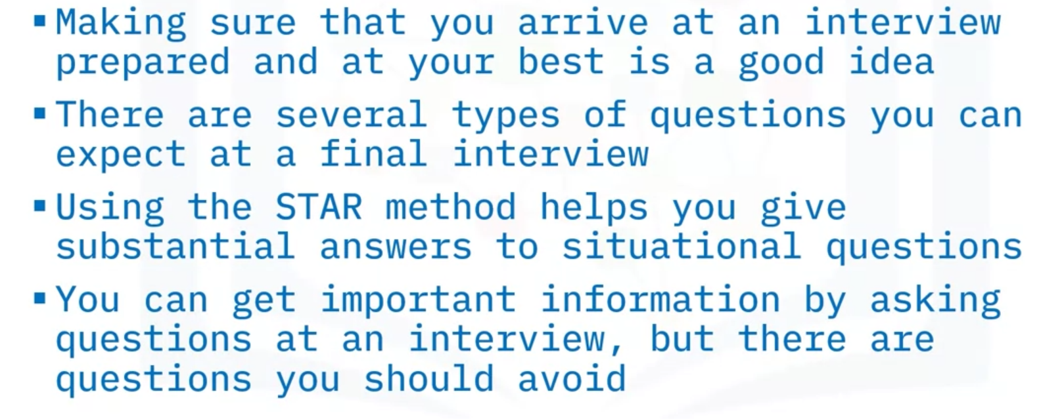

# After the Interview

Waiting for a response after any job interview can be stressful. After sending a thank-you note to the person or interview panel who took the time out to interview you, reflect constructively on the experience and consider what would happen next if you receive an offer – or if you don’t. It’s useful to take time and track the process: note the company and when they interviewed you, any personnel you met, and the outcome. Make notes about the questions you were asked and your answers, also noting whether you would answer differently another time. Remember, your “job” of finding a job isn’t over until you secure a new position, so be ready to coach yourself all the way.

# If you get an offer

Receiving a job offer is always exciting. However, don’t get swept up in the thrill and forget that you don’t have to accept the job right away. Consider all the facets of what’s offered to you before deciding. You can tell the hiring manager that you need some time to review the offer before making a decision. The recruiter may suggest a time frame and encourage you to ask questions in the interim about the offer package if you need to. Generally, you should come to a decision within two business days. Companies usually need to complete the hiring process as quickly as possible, and they may move on to another candidate if they wait too long for your answer.

If you received an offer and the salary or employee benefits do not match what you consider is fair, research the market, bring forth your selling points, and express the valid reasons why you are requesting a higher salary. It is totally acceptable to request a fair compensation package. When you consider whether your compensation is fair, however, make sure to weigh in the value of the employee benefits package. Consider signing bonuses, moving allowances, stock options, and other non-salary compensation that’s offered, as well as less quantitative benefits like a better commute or flexible work times.

The thought of negotiating a job salary offer may make you uncomfortable, but if the offer is below what you expected after factoring in all of the other considerations, you might want to negotiate a fairer salary. You might respond by phone or in email. Begin your response by expressing your excitement and appreciation for being selected. Include points on how you plan to contribute to achieving the company’s goals. Base your counteroffer on verifiable research or supporting arguments that there is a higher value to what you bring to the table.

Some legitimate arguments to support a salary negotiation are:

* Commute and relocation expenses.
* Having a university degree that may have not been required to apply, but provides an academic preparation that will contribute to exceeding job performance expectations.
* Possessing a skillset or certifications that required extensive or costly training, especially if they were stated as preferred qualifications in the job listing.

However, the company responds, make sure you express appreciation for their allowing you to approach them with your request. The company may not be able to accommodate your request because of budget or company policies about standard pay scales for certain positions, but it doesn’t hurt to ask.

If you are between interview rounds or awaiting an offer from another company, you must contact them and let them know you wish to withdraw your application for their position. Let them know you appreciate their consideration but have decided to accept another offer. Always ask them to keep your information in case other opportunities arise in the future and treat them professionally and courteously – you never know when you’ll be in the job market again and want to contact them about another position, so maintain a good reputation.

If you must resign from a current job, you should provide your employer a standard two weeks’ notice whenever possible. Again, always behave professionally and maintain your good reputation, in case you need a reference someday or even return for a different job. Try to arrange a start date with your new employer so that you are able to take some time off between jobs. Reporting to your first day at the new job after a few days of rest will help ease your transition and onboarding process, as opposed to jumping right in the day after you left your previous workplace.

# If you are declined

The most important thing to do after learning that you were not selected for job is to learn from the experience. The job interviews you attend always provide valuable lessons and are the best reference you can have when applying for other jobs in the future. Remember, too, that this is no personal reflection on you; there can only be one candidate hired for a job, even if other candidates were excellent and capable. You never know what exact factors made a manager choose someone else, so don’t dwell on it too much.

Contact your interviewers by phone or email and let them know that you appreciate the notification. After all, many companies nowadays don’t make an effort to contact the job applicants who weren’t selected for an opening. Request feedback! Ask for an honest assessment and keep an open mind, especially if any points in their feedback are unexpected. Maybe the points you overlooked played a big part in not being selected for the position. Also, you may want to ask for advice on what you should work on to improve. Be aware, though, that many companies prohibit their personnel from giving feedback about interviews (often for legal reasons), so you may not be able to get more information.

If you do receive any feedback, reflect on the entire process, from your application packet to the way you prepared and researched for your interviews. Consider the things you can do something about, and focus on how you can prepare better for a next interview in the near future. Devise a plan and act on it. Should you spend more time writing better answers? Should you do more rehearsal so you appear less awkward? Can a training, book, or some coaching from a teacher or professor help?

Conclusion

Every interview process is a chance to learn, whether you get the job or not. If you weren’t selected, consider the interviews and assessments as valuable experience that you needed to land the job of your dreams. If you were selected, that means you prepared well and your efforts have paid off. Either way, you’ve gained skills that you can use in your next job search, whether that’s a day away or years in the future.